Pokhara University

Level: Bachelor | Semester – Fall | Year : 2008
Programme: BE |  | Full Marks : 100
Course: Applied Mechanics |  | Time : 3hrs.

Candidates are required to give their answers in their own words as far as practicable.
The figures in the margin indicate full marks.

Attempt all the questions.

1. | - Determine the moment of the force F = 5i +6j -7k acting at the point (2,2,1) with respect to the line passing from (1,1,-2) and (2,-1,3). The units of force and lengths are N and cm respectively.  - State the general equation of equilibrium. What do you mean by free body diagram and what are its uses? | 8  7
2. | - A block of weight W₁ = 1000N rests on a horizontal surface and supports on top of it another block of weight W₂ = 500N, as shown in figure. The block W₂ is attached to a vertical wall by the inclined string AB. Find the magnitude of horizontal force P, applied to the lower block as shown that will be necessary to cause slipping to impend. The coefficient of static friction for all contact surfaces is 0.3.  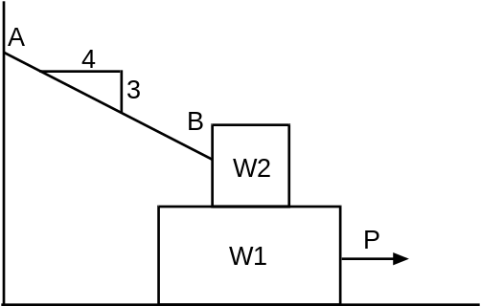  - Locate the centroid of the area bounded by curves as shown.  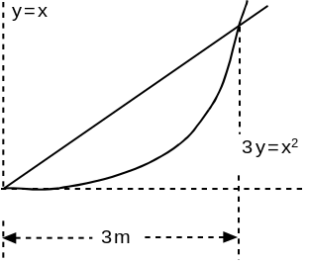 | 8  7
3. | - The acceleration of a particle is define by the relation a = 9-3t². The particle starts at t = 0 with v = 0, x = 5. Determine (i) time when velocity is again zero. (ii) Position and velocity when t = 4s. (iii) Total distance travel by the particle from t = 0 to t = 4s.  - A motorist is travelling on a curved section of highway of radius 750m at the speed of 100km/h. The motorist suddenly applied the brakes, causing the automobile to slowdown at constant rate. Knowing that after 8s speed has been reducing to 75Km/h, determine the acceleration of the automobile immediately after the brakes have been applied. | 7  8
4. | A 50N package is projected up a 20⁰ incline with an initial velocity of 40m/s. knowing that µ = 0.15 determine:  - Maximum distance x that the package will move up the incline  - Velocity of the package as it returns to its original position  - Loss of kinetic energy  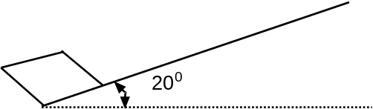 | 15
5. | In a game of pool, ball A is moving with velocity 4.57 m/s when it strikes ball B and C which are at rest as shown. Knowing that after the collision the three balls move in the direction indicated and assuming frictionless surface and perfect elastic impart. Determine magnitude of the velocity V_{A}, V_{B}, V_{C}.  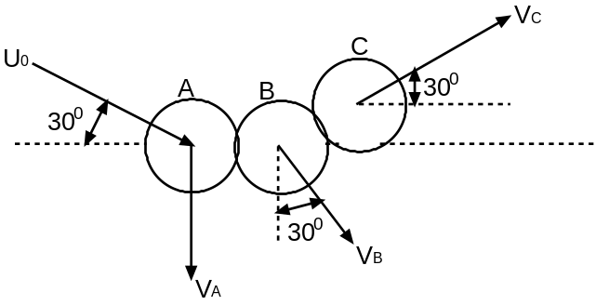 | 15
6. | - Collar A moves with constant velocity of 900mm/s to the right. At the instant when θ = 30⁰, determine angular velocity of rod AB and velocity of Collar B.  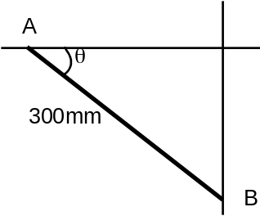  - State and prove D'Alemberts principle. | 8  7
7. | Write short notes on (Any Two)  - Principle of work and energy for rigid bodies  - Particle and Rigid bodies  - Linear and angular momentum of f particle  - Couple and its properties | 5×2

